**Tle: The Transformative Role of IT in the Goods Sector**

In recent years, the goods sector has experienced a significant evolution, primarily driven by advancements in IT. From supply chain management to customer engagement, technology has become a cornerstone of efficiency and innovation. Firstly, let’s discuss supply chain optimization. Technologies like the Internet of Things (IoT) allow for real-time tracking of goods, which enhances inventory management. Businesses can now predict demand more accurately, reduce waste, and ensure that products reach consumers faster than ever. Imagine a warehouse where sensors monitor stock levels and automatically reorder items when they run low—this is not just a dream but a reality in many companies today. Secondly, data analytics plays a crucial role in understanding consumer behaviour. With vast amounts of data at our fingertips, companies can analyse purchasing patterns and preferences. This allows for personalized marketing strategies, improving customer satisfaction and loyalty. For instance, e-commerce platforms use algorithms to recommend products tailored to individual tastes, driving sales and enhancing the shopping experience.

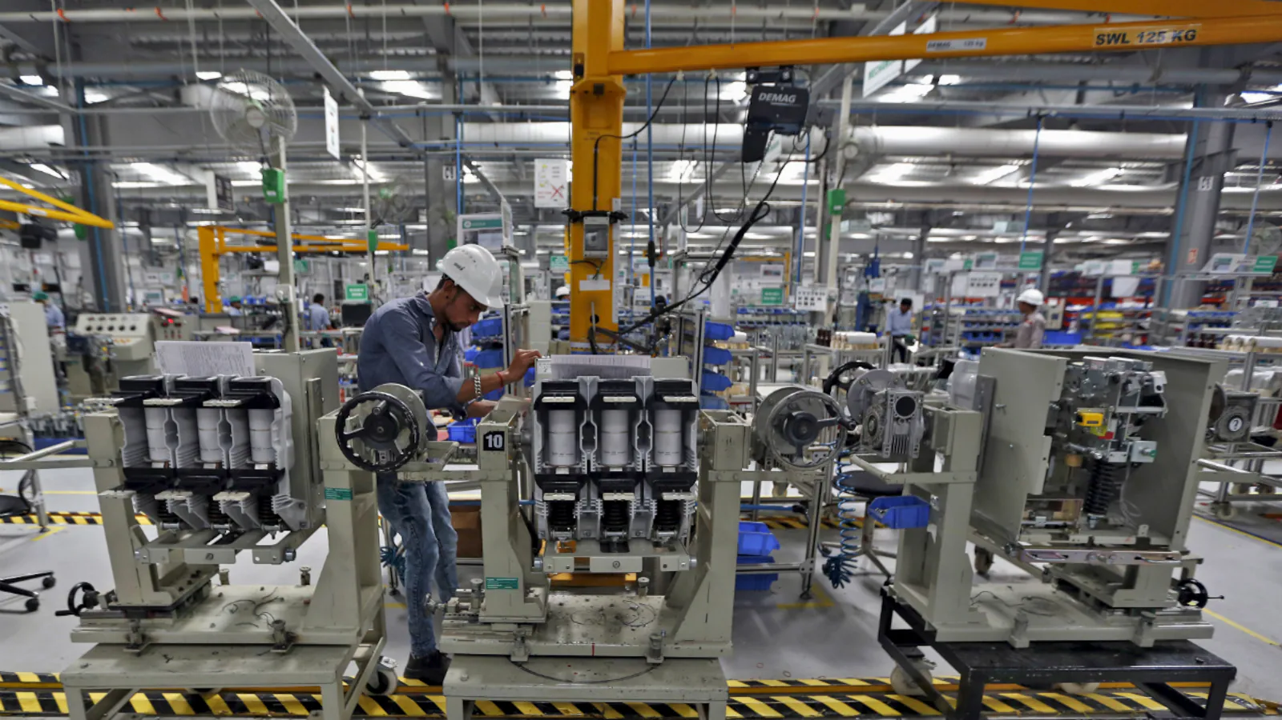

Moreover, the integration of AI and machine learning is revolutionizing quality control. Automated systems can detect defects in products much faster and more accurately than human inspectors. This not only ensures higher quality standards but also reduces costs associated with returns and customer dissatisfaction. Lastly, let’s not overlook the impact of IT on sustainability in the goods sector. With the increasing focus on environmentally friendly practices, technology enables companies to track their carbon footprint and optimize resource use. Digital platforms can facilitate circular economy practices, where goods are reused, repaired, or recycled efficiently.

In conclusion, the intersection of IT and the goods sector is not just about improving processes; it’s about reimagining the entire ecosystem. As we continue to embrace these innovations, we pave the way for a more efficient, customer-centric, and sustainable future.